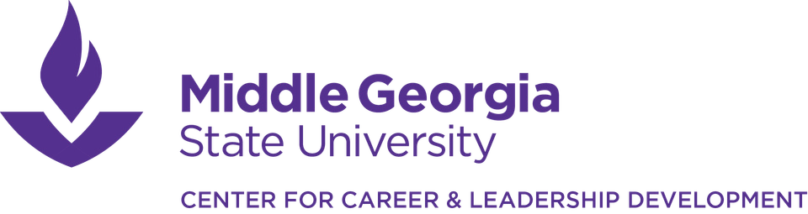
Complementary employer services include job and internship postings in Handshake
and the opportunity to be a featured Knights@Work Internship Partner.
To discuss Employer Partner opportunities, contact Dr. Mary Roberts at mary.roberts3@mga.edu or 478-471-2441.
Employer Partner Benefits
(year-long, begins upon receipt of payment)

Complementary career fair/networking event registration(s) for up to 4 recruiters.
# of career fairs based on partner level: Bronze: 1, Silver: 2, Gold & Platinum: 2+

Logo inclusion in digital career fair marketing and career fair event signage

Targeted email(s) to students prior to career fair(s) or other date(s) of your choice.
# of emails based on partner level - Bronze: 1, Silver: 2, Gold & Platinum: 4

Expanded logo visibility on website, Student Leadership Conference marketing, @MGACCLD social media, and all 3 office locations (Macon, Cochran, & Eastman)

Priority invitation to career-related student events
(mock interview days, resume review days, etiquette dinner, campus interviews after career fairs, etc.)

Participation in the
Student Leadership Conference Networking Luncheon.
Includes presenting to 150+ student leaders from all majors.

Individualized campus visit day.
Includes expanded branding, connection, consultation, and outreach opportunities.

Presenting Sponsor at Student Leadership Conference.
Includes all benefits plus logo on 200 t-shirts, opportunity to address students during the conference welcome, and your company name in 2027 conference title. Also includes opportunity to participate in the Student Leadership Challenge in April.

Participation as a Student Leadership Challenge Facilitator.
Bronze and silver benefits plus opportunity to address the student participants during the winner ceremony.
Bronze

$400

x

x

x
Silver

$800

x

x

x

x

x

x
Gold

$1500

x

x

x

x

x

x

x
Platinum

$3500

x

x

x

x

x

x

x

x

x
EMPLOYER PARTNER PROGRAM

