Create an app password for Office 365

An app password is a code that gives an app or device permission to access your Office 365 account.
If your admin has turned on multi-factor authentication for your organization, and you're using apps that connect to your Office 365 account, you'll need to generate an app password, so the app can connect to Office 365. For example, if you're using Skype for Business or other apps that do not support modern authentication with Office 365, you'll need to create an app password.
You can also use App passwords with built in Gmail, Android and iOS email clients to send and receive email on a device that is using these clients when you’re NOT signed into the MGA domain. Built in email clients will not work with your MGA email without an app password. You can download and use the Outlook mobile client for your device if you don’t want to use an App password.

- Check whether your Office 365 admin has turned on multi-factor authentication for your account. If they haven't, when you try to do these steps you won't see the options in Office 365.
- Sign in to Office 365 with your work or school account with your password like you normally do. After you choose Sign in, you'll see this page:
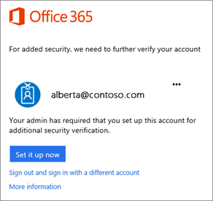
- Choose Set it up now.
- Select your authentication method and then follow the prompts on the page.
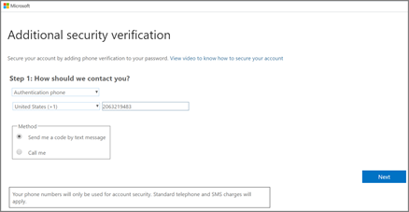
- After you verify your alternate contact method, choose Next.
- You'll get an app password that you can use with Outlook, Apple Mail, etc. Choose the copy icon to copy the password to your clipboard. You won't need to memorize this password.
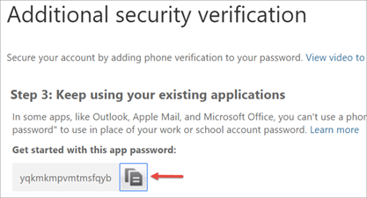
To create another app password
- Sign in to Office 365.
- Choose Settings > Office 365.
- Choose Security & Privacy > Additional security verification. You'll only see this option if your admin has set up multi-factor authentication for your organization.
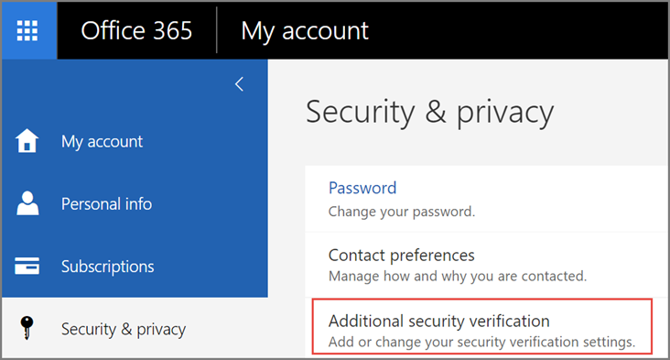
- Choose Update my phone numbers used for account security. This will display the following page:
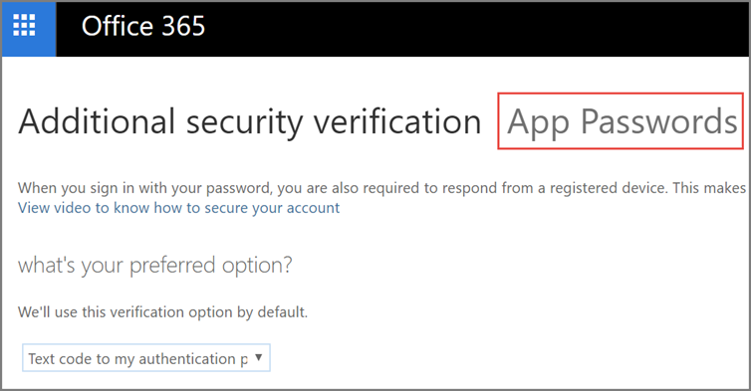
- At the top of the page, choose App Passwords.
- Choose create to get an app password.
- If prompted, type a name for your app password (name of app. Ex. “Skype”), and click Next.
- Choose copy password to clipboard. You won't need to memorize this password.
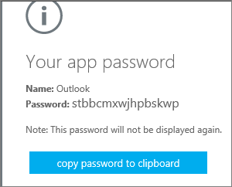
Tip: If you create another app password, you'll be prompted to name it. For example, you might name it "Outlook."
- Go to the app that you want to connect to your Office 365 account. When prompted to enter a password, paste the app password in the box.
To use the app password in Outlook
You'll need to do these steps once.
- Open Outlook, such as Outlook 2010 or non-updated versions of 2013.
- Wherever you're prompted for your password, paste the app password in the box. For example, if you've already added your account to Outlook, when prompted paste the app password here:
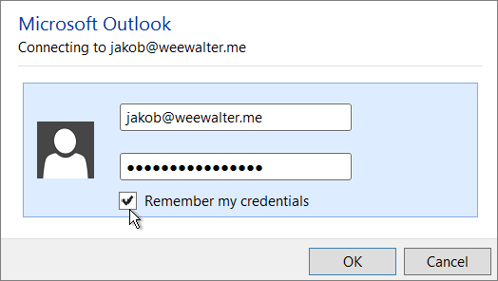
- Or, if you're adding your Office 365 account to Outlook, enter your app password here:
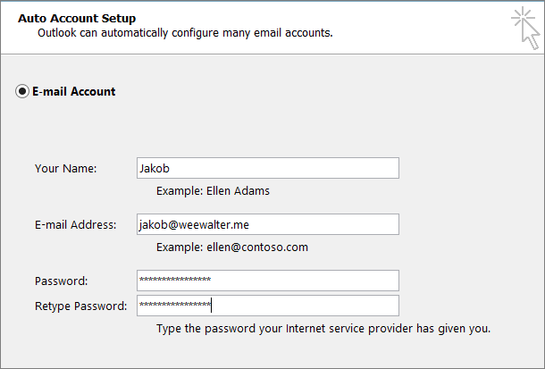
- Restart Outlook.
To use the app password in Skype for Business:
- Launch the Skype for Business app and type in your username in the “Sign-in address:” field and click “Sign in” at the bottom.
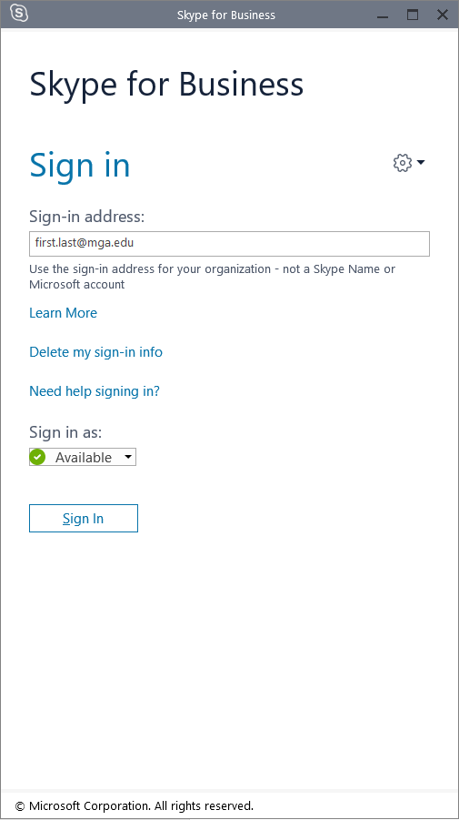
- Wherever you're prompted for your password, paste the app password in the box. For example, if you've already added your account to Skype for Business, when prompted paste the app password here and click the “Save my password” box and then “Sign in”.
